**Coursera Course: IBM Data Science Capstone Project**

**Recommendation System for Restaurants in Hyderabad under GHMC.**

**By Devender Madura**

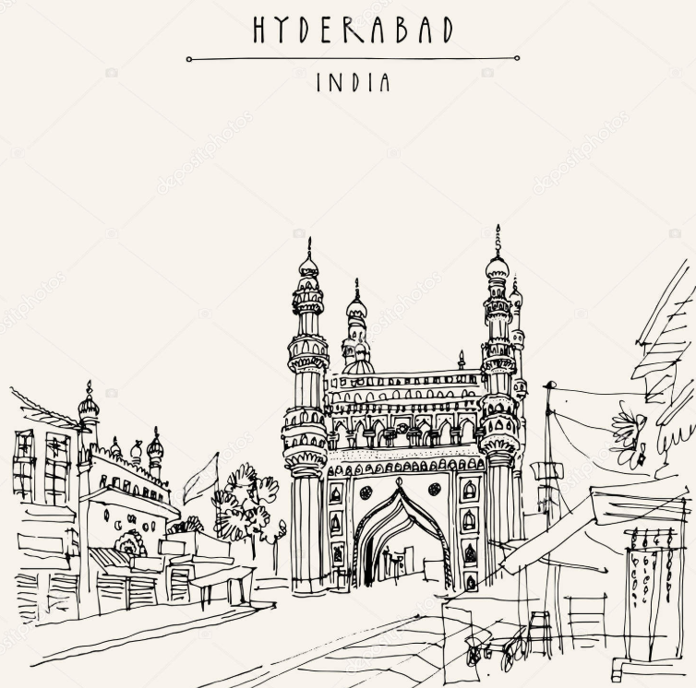

**Table of Contents**

Introduction 2

Description of Business Problem 2

Description of Data & Sources 3

Hyderabad Locations 3

Hyderabad Restaurants 3

# **Introduction**

## **Description of Business Problem**

The Greater Hyderabad Municipal Corporation (GHMC) is the civic body that oversees Hyderabad, the capital and largest city of the Indian state of Telangana.

Hyderabad was recently votes as one of the most livable metro cities in India according to the Mint Livability Index. Hyderabad scores highly on account of high commute speeds, its attractiveness to migrants, low rents, high access to social infrastructure and a rich cultural background and food industry. Hyderabad, the city of biryanis, kebabs, haleem, kallu, shikampur and chowki dinners, has now been officially designated as a UNESCO Creative City of Gastronomy. Hyderabad is among the 66 cities named by the UNESCO in the list of new Creative Cities which aims at pushing the Sustainable Development Goals through innovative thinking and action.

Hyderabad has a fast emerging market for the hospitality, travel, and tourism sectors. Statistics shared by the Telangana Tourism Department shows that the city witnessed an impressive 76% rise in foreign tourist arrivals (FTAs) in 2017, while the domestic tourist arrivals (DTAs) increased by 16% last year. One of the reasons for the accelerating growth of the Hyderabad hospitality industry is being attributed to its rising popularity as a business hub and consequently a real estate hot-spot. Medical tourism is another major driver of the growth.

The modern cuisine was evolved during the Nizams in the mid-17th century, and elevated to a sublime art form. Hyderabad has a history of continuous influx of migrants from all over the world and in general from the Indian sub-continent, particularly since 1857. Most of the foreign food had been improved to suit the culinary preferences, resulting to form the unique derivative cuisine that excels over the original. Biryani (Turkish) and Haleem (Arabic) for instance is prepared all over India, but the Hyderabadi variety is ultimately from the Hyderabadi Biryani and Hyderabadi Haleem

“A well-fed man is a Happy Man. There is no better place than Hyderabad as it offers a huge variety finger-licking foods from different cuisines which can be savored by all age groups. There is a reason why Hyderabad was declared to be the best city to live in, and of course food is one of the many reasons! Hence, to satisfy your insatiable hunger, here are 20 foods you must try at Hyderabad

**It’s evident that the city of Hyderabad has a great affinity with varieties of food and is a great city and presents lot of opportunities for opening restaurants & eateries.**

A restaurant or an eatery, is a business that prepares and serves food and drinks to customers. Meals are generally served and eaten on the premises, but many restaurants also offer take-out and food delivery services. Restaurants vary greatly in appearance and offerings, including a wide variety of cuisines and service models ranging from inexpensive fast food restaurants and cafeterias, to mid-priced family restaurants, to high-priced luxury establishments.

**While there are many factors to consider while opening a restaurant like concept, budget, cost, time, staff, vendors, licenses etc. We shall be considering 2 major factors Location and Cuisine that need to be thought through in detail to be able to open a successful restaurant. We shall be trying to use some Data Science methodologies to try and get some key findings that can help make this decision.**

## **Description of Data & Sources**

### **Hyderabad Locations**

The Greater Hyderabad Municipal Corporation (GHMC) comprises the erstwhile Hyderabad Municipal Corporation, plus 10 municipalities & 8 panchayats in erstwhile Ranga Reddy district, 2 municipalities in erstwhile Medak district. At present, Greater Hyderabad Municipal Corporation is spread across 4 districts - Hyderabad district, Medchal district, Ranga Reddy district, and Sangareddy district.

We can identify and pull all the neighborhoods from Wikipedia link below, where they are referred to as Wards using a simple gethtml function

<https://en.wikipedia.org/wiki/List_of_Hyderabad_Corporation_wards>

There are about 150 wards and out of that we are able to plot 117 of those using geolocation and these neighborhoods will be basis of the analysis and comparison.

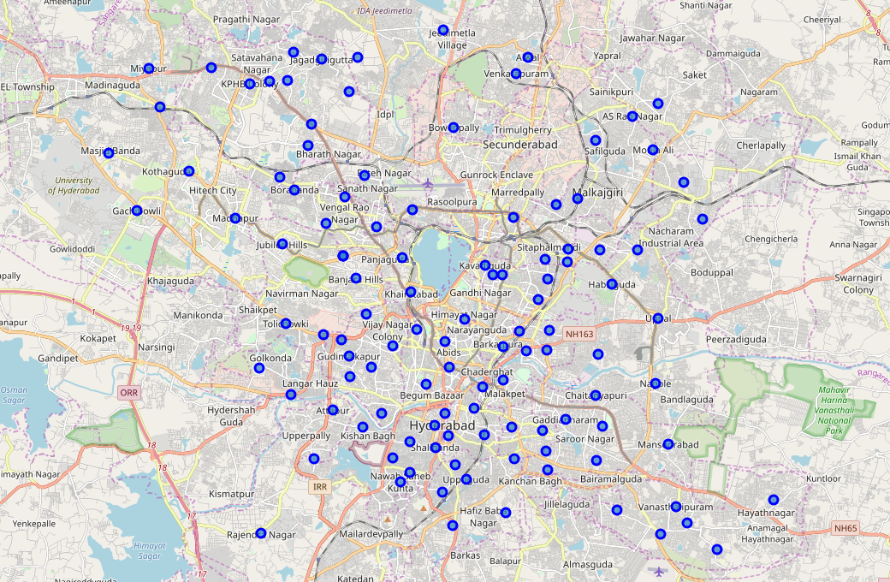

### 

### **Hyderabad Restaurants**

For the venues we will be pulling the data from FourSquare API and Zomato API.

From FourSquare API we are able to source 200 restaurants and with Zomato API we are able to source and identify 1050 restaurants along with rating, average cost and voters information. We are going to use the cuisines information to identify a combination of location and best suitable cuisine and then we are going to use all the other rating cost and voters information to identify better insights and possibly better recommendation and analysis.

Map plot of all restaurants identified by Four Square API

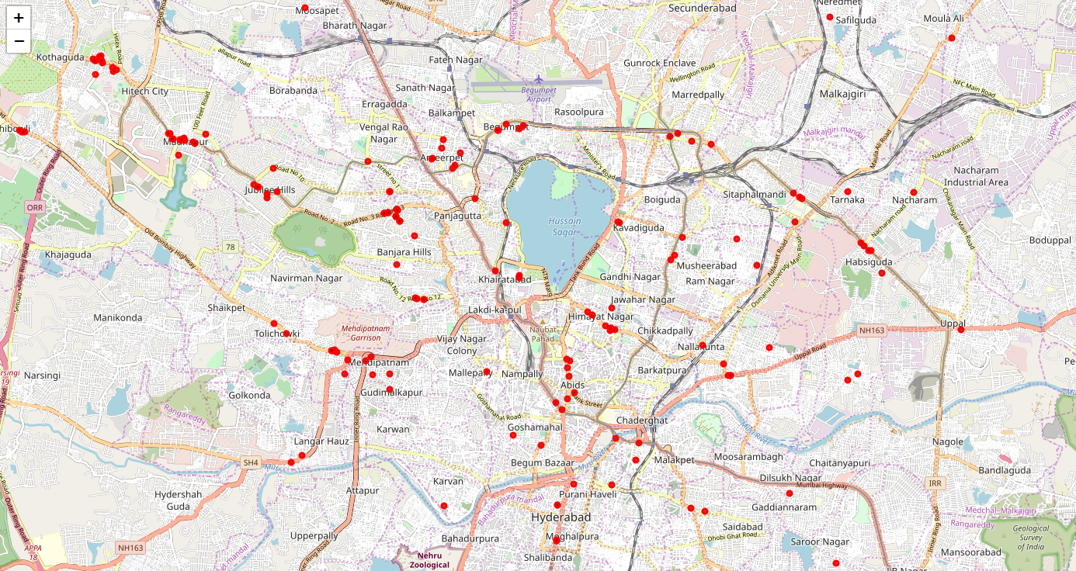

Map plot of all restaurants identified by Zomato API

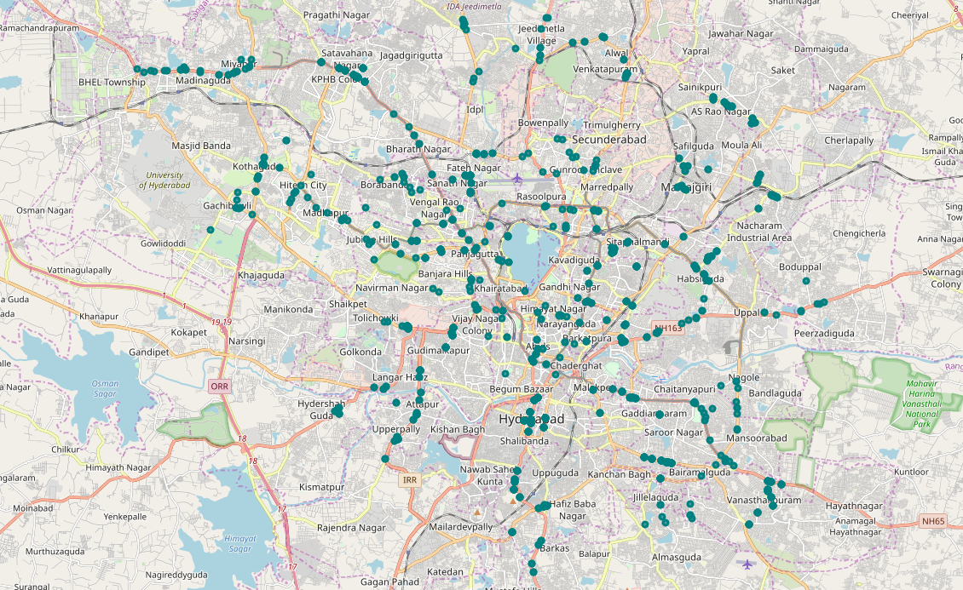

In the Zomato API we are able to get more rich data and I have reviewed through all the available information in JSON and chosen the fields for Cuisines, Average Dining Cost, User Rating, and User Votes and if there is availability of home delivery. Please see below sample data I have able to source from the Zomato API.

